# Test Results

**Setup**

1. **Set AllegroU Video URL and search terms for AllegroU or the Knowledge Base in Allegro Business** **Process model.**
2. Navigate to Contracts > Administration > Process Model > Process Model
3. For example, setup Video Url and search terms for *Counterparty Detail Process*
4. In Process pane, select Contract, Counterparty Detail
5. In Sub process pane, fill the Video Url and search term
6. Update changes

Screenshot of the Process Model:

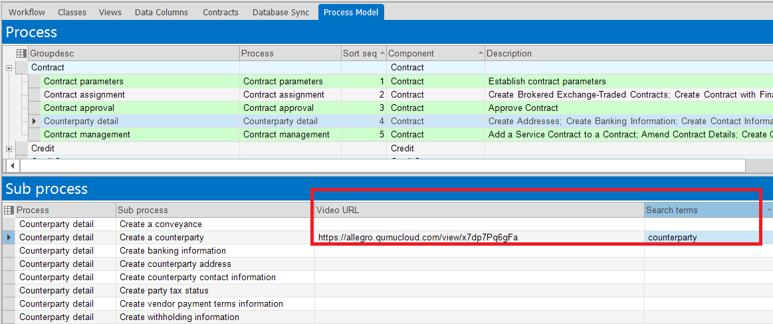

1. **Setup Username and Password AllegroU**
2. Navigate to Administration > Activity Monitoring > Server Manager
3. Navigate to the "Config" pane
4. Insert rows for Config Key AllegroUHelper_Username and AllegroUHelper_Password, and fill the Config Value with valid username and password for AllegroU Qumu
5. Update data

Screenshot of the Config Server Manager

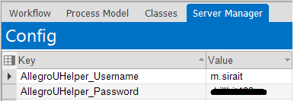

The AllegroU AddOn tools should display as a menu item that appears in the Ribbon on every view in Allegro, as example this test use **Counterparties View**

1. **Test Procedure: Video Capture to launch the Qumu video capture tool.**

Step:

1. Navigate to Contracts > Counterparties > Counterparties
2. Click on the "AllegroU" ribbon on the upper toolbar
3. Click on "Video Capture"

AllegroU Ribbon Video Capture:

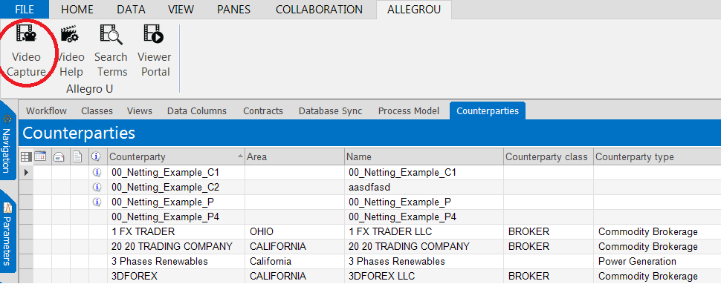

1. Allegro Application will open web browser to open Allegro Qumu Video Capture tool

Allegro Qumu:

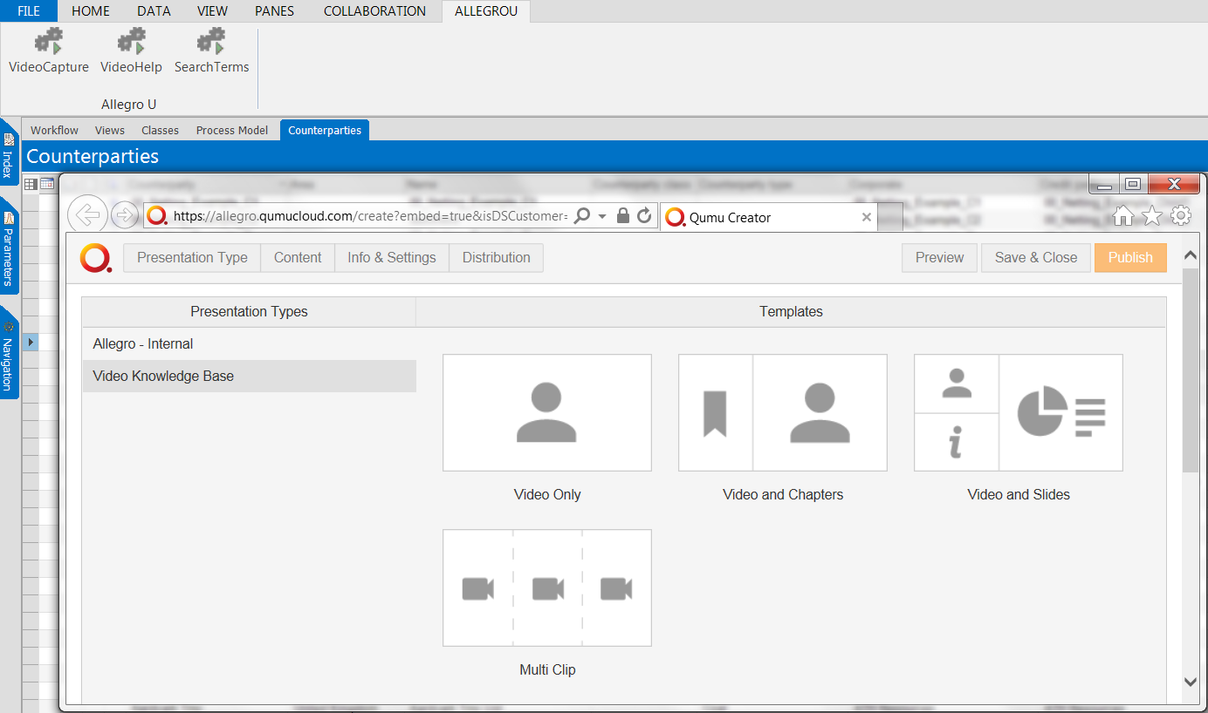

1. **Test Procedure: Video Help to display list of business processes which represent by Url Video that store in Process Model tables. The results based on viewname the user is currently on and be able to click/double click on the applicable video to play.**

Step:

1. Navigate to Contracts > Counterparties > Counterparties
2. Click on the "AllegroU" ribbon on the upper toolbar
3. Click on "Video Help"

AllegroU Ribbon Video Help:

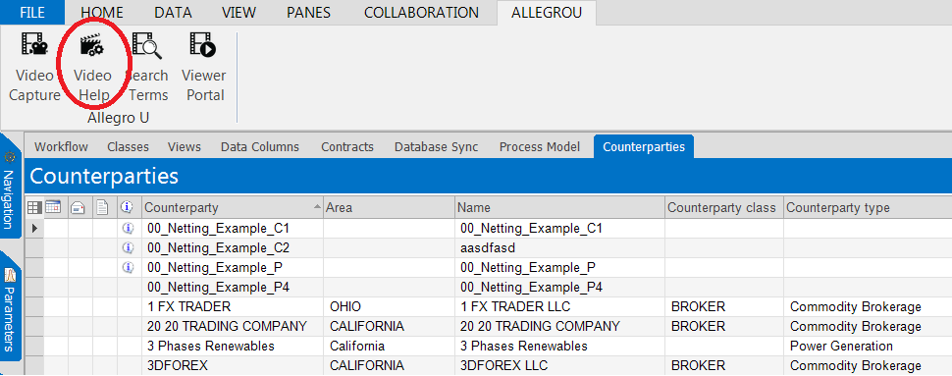

1. Allegro Application will open AllegroU View to display list of business processes with Url Video
2. Procedure Panes will Showed up based on subprocess in video help

AllegroU View Video Help:

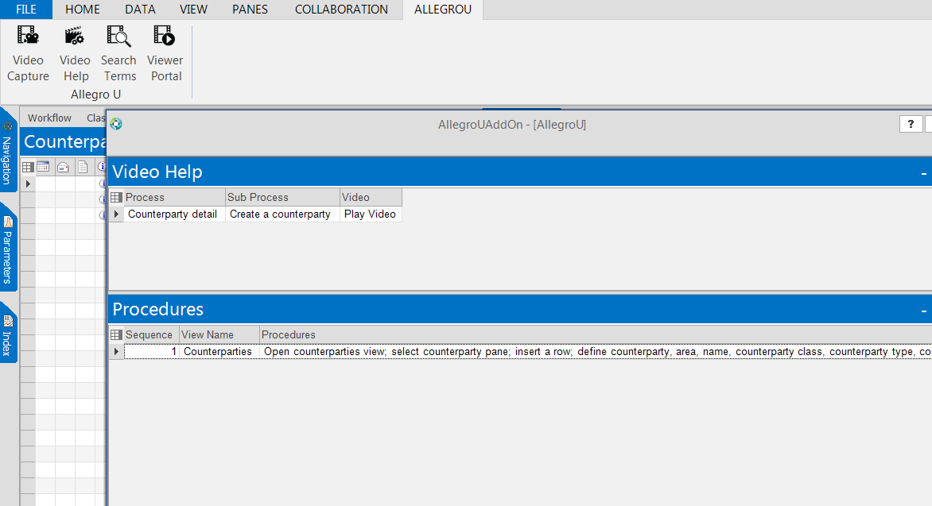

1. Click on Play Video Cell with process *Create a counterparty* to open and play video in webbrowser

AllegroU Video:

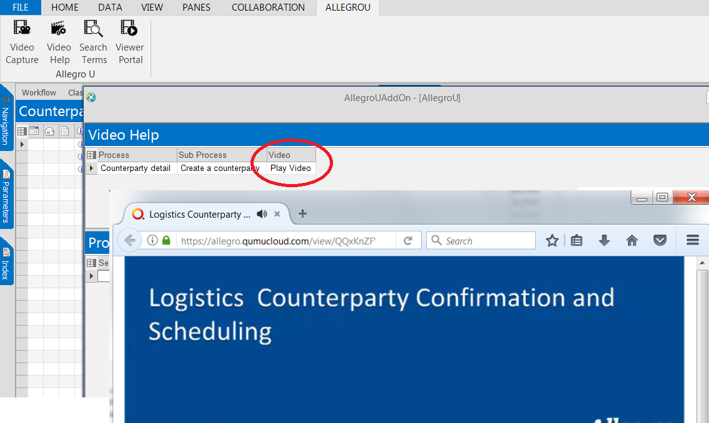

1. **Test Procedure: Search to display list of search terms for AllegroU and Allegro Knowledge base that store in Process Model tables. Clicking on the search terms will simultaneously search AllegroU as well as the Allegro Knowledge base and resulting results should be able to click/double click to connecting to either AllegroU or the Knowledge Base.**

Step:

1. Navigate to Contracts > Counterparties > Counterparties
2. Click on the "AllegroU" ribbon on the upper toolbar
3. Click on "Search Terms"

AllegroU Ribbon Search Terms:

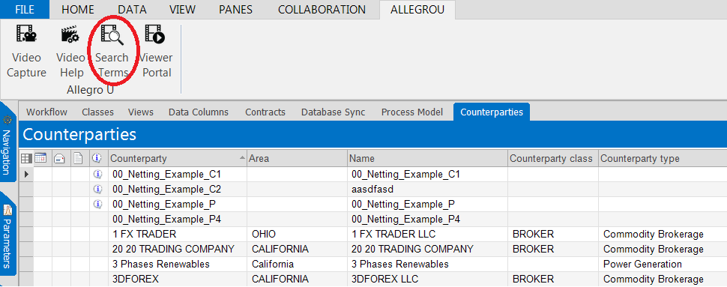

1. Allegro Application will open AllegroU View to display list of search terms

AllegroU View Search Terms:

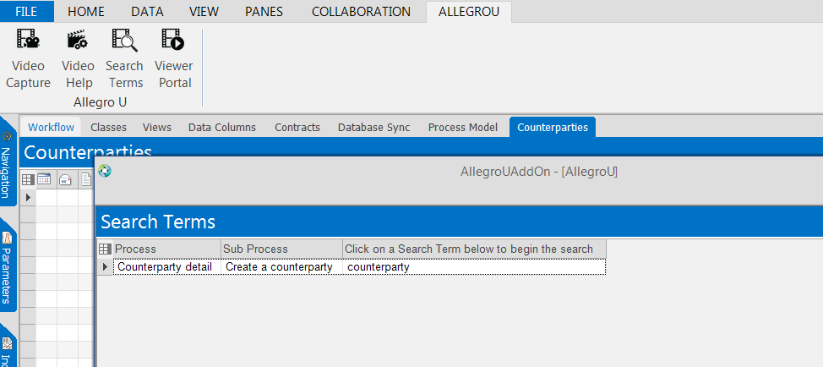

1. Click on the Search Terms with process *Create a counterparty* to display resulting results from AllegroU and Allegro Knowledge base

AllegroU View Search Results:

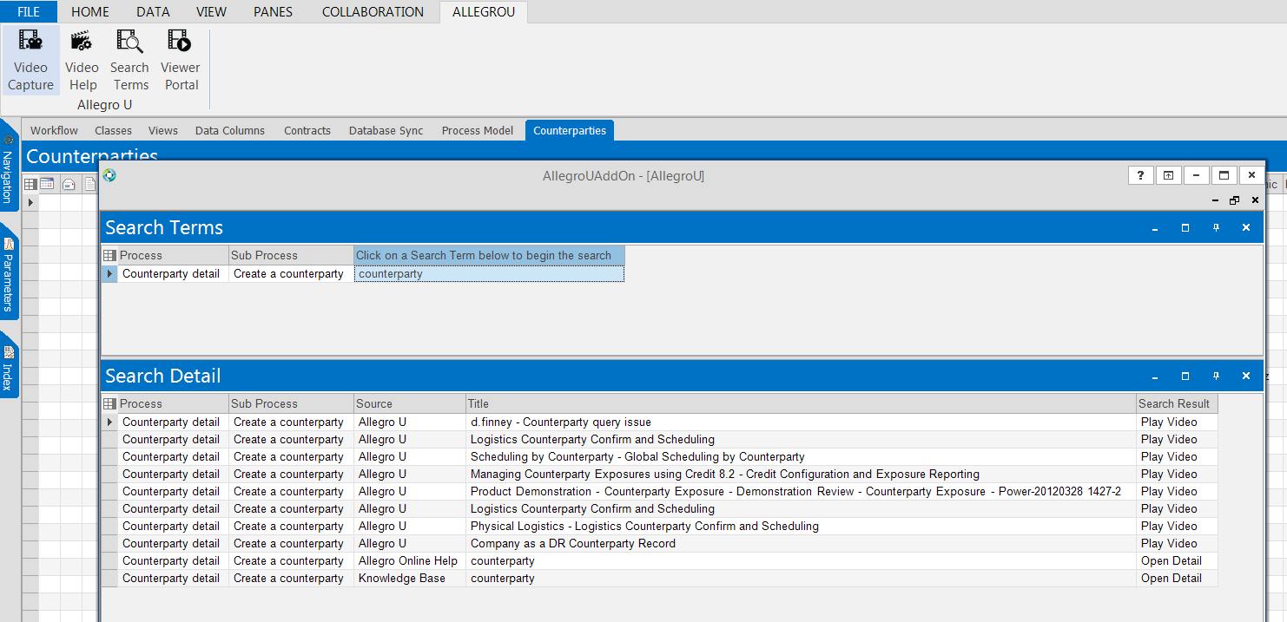

1. Click on one of Search Result Cell with source AllegroU to open and play video in webbrowser

AllegroU Video:

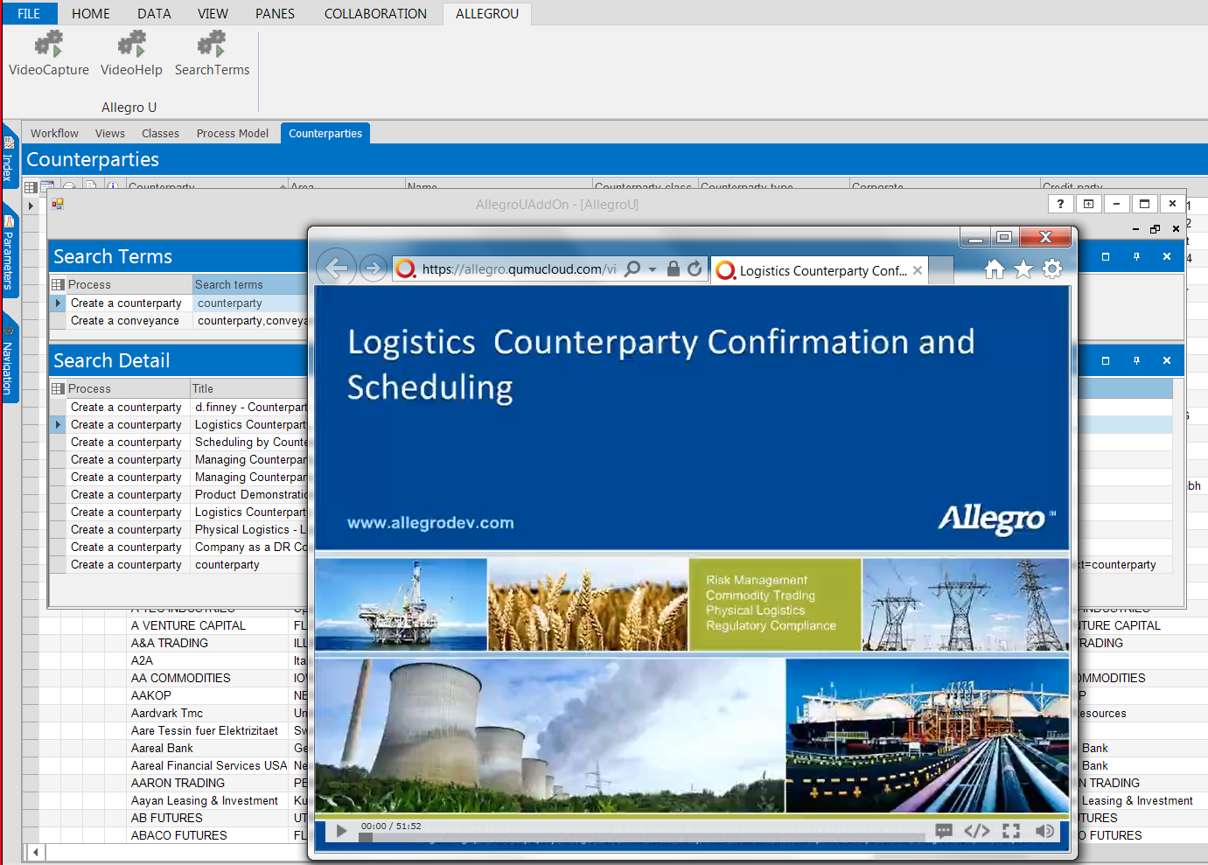

1. Click on one of Search Result Cell with source Knowledge Base to connection to Knowledge Base search results in webbrowser

Allegro Knowledge base:

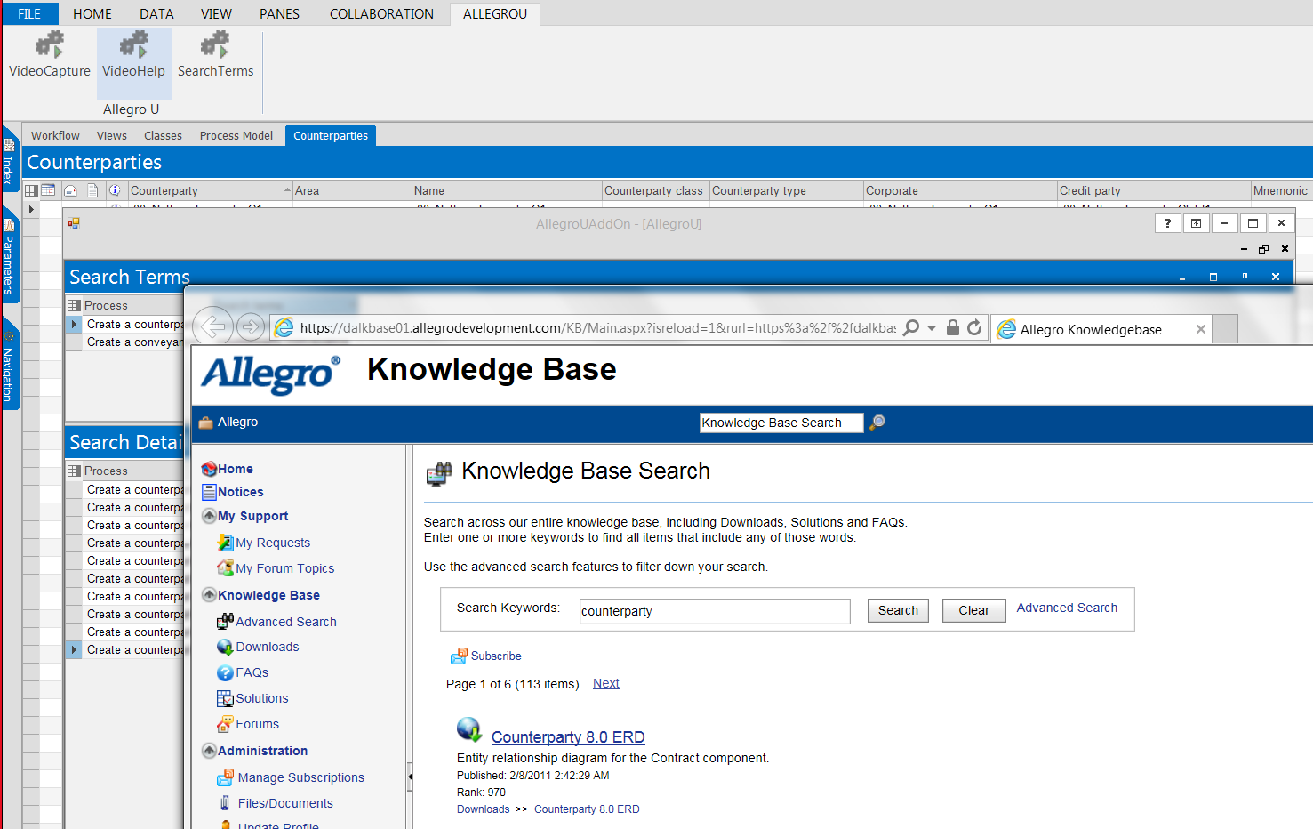

1. Click on one of Search Result Cell with source Allegro Online Help to connection to Allegro Online Help search results

AllegroU View Search Results:

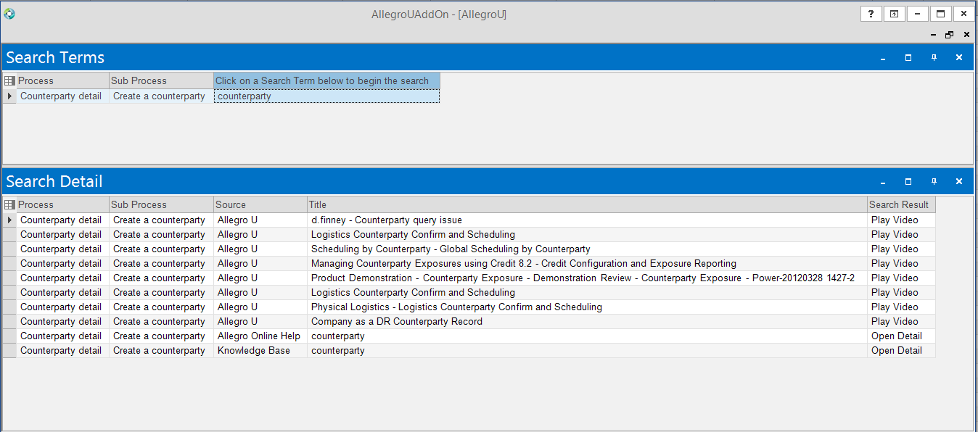

Allegro Online Help:

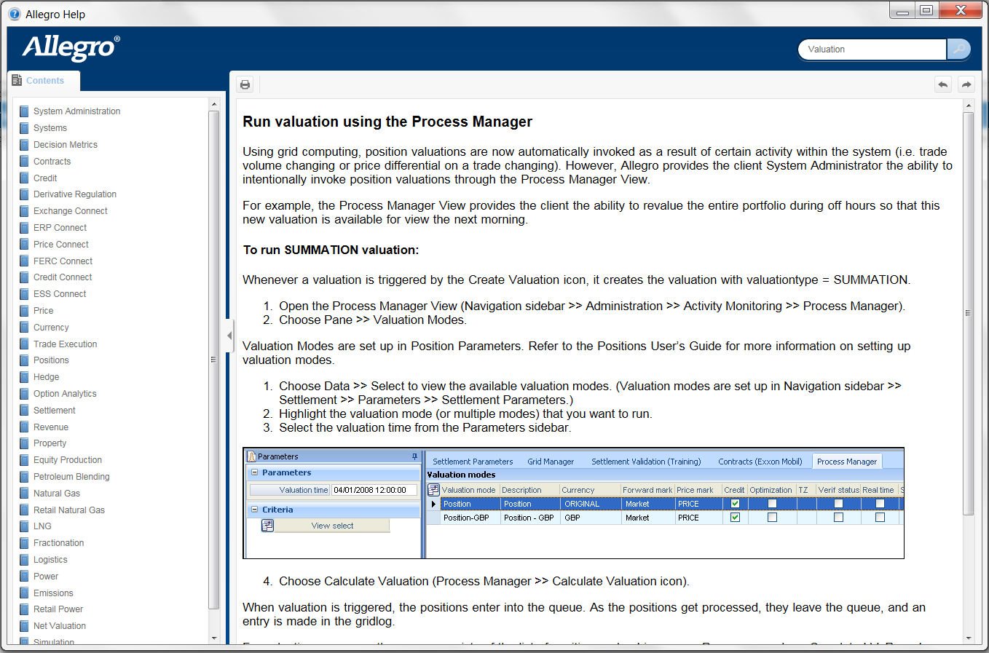

1. **Test Procedure: Viewer Portal to launch the config Url AllegroUVideoPortal**

Step:

1. Navigate to Contracts > Counterparties > Counterparties
2. Click on the "AllegroU" ribbon on the upper toolbar
3. Click on "Viewer Portal"

AllegroU Ribbon Viewer Portal:

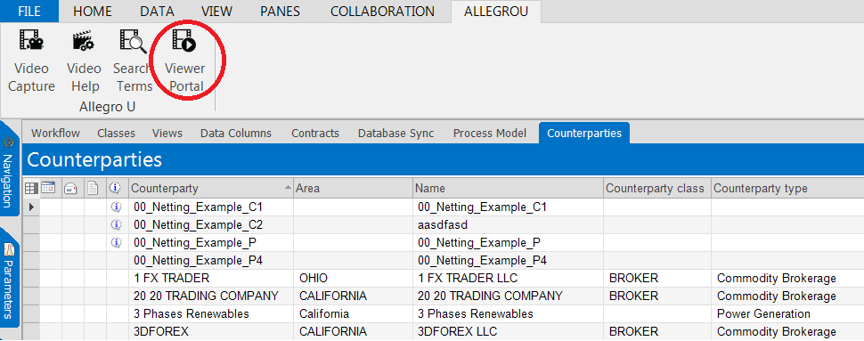

1. Allegro Application will open web browser to open AllegroU Video Portal if server manager config key AllegroUVideoPortal is not define yet.

Allegro Video Portal:



1. Navigate to Administration > Activity Monitoring > Server Manager
2. Navigate to the "Config" pane
3. Insert rows for Config Key AllegroUVideoPortal, and fill the URL value to access customer viewer portal. For example “https://www.allegrou.com/viewerportal/allegrou/home.vp”
4. Update data

Screenshot of the Config Server Manager

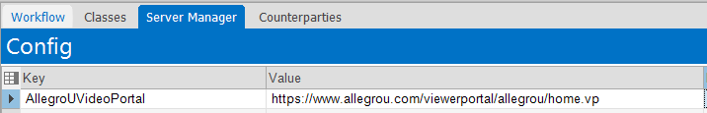

1. Navigate to Contracts > Counterparties > Counterparties
2. Click on the "AllegroU" ribbon on the upper toolbar
3. Click on "Viewer Portal"
4. Allegro Application will open web browser to open URL as define in Server Manager config key AllegroUVideoPortal.

AllegroUVideoPortal URL Config:

